Table created :
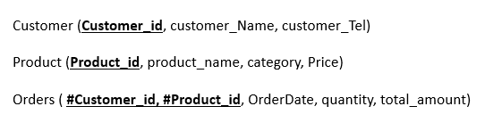
Write SQL commands to insert the following rows into the corresponding tables
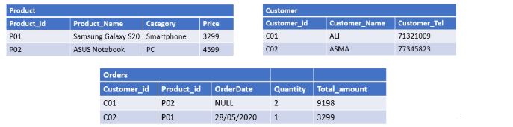

INSERT INTO Product
VALUES (P01, Samsung Galaxy S20, Smartphone, 3299);
INSERT INTO Product
VALUES (P02, ASUS Notebook, PC, 4599);
INSERT INTO Customer
VALUES (C01, ALI, 71321009);
INSERT INTO Customer
VALUES (C02, ASMA, 77345823);
INSERT INTO Orders (Customer_id, Product_id, Quantity, Total_amount)
VALUES (C01, P02, 2, 9198);
INSERT INTO Orders
VALUES (C02, P01, 28/05/2020, 1, 3299);

